**Lab – 49: Download and Install the ATA Center?**

**Objective:** The objective of this lab is –

* To download and install the ATA Center.

Advanced Threat Analytics (ATA) is an on-premises platform that helps protect your enterprise from multiple types of advanced targeted cyber-attacks and insider threats. ATA is composed of the ATA Center, the ATA Gateway and/or the ATA Lightweight Gateway. In this lab, we are going to download and install ATA Center in Windows Server 2016.

**Prerequisite:** Windows Server 2016. Windows server should be a member of a domain or workgroup. At least one network adapter. Microsoft .Net Framework 4.6.1 or later. Browser - Internet Explorer version 10 and above (or any other latest browser).

**Steps:**

1. First log in to the computer on to which you are installing the ATA Center as a user who is a member of the local administrators group.
2. Then go to https://www.microsoft.com/en-in/cloud-platform/advanced-threat-analytics and click **Try Now**. Or direct go to https://www.microsoft.com/evalcenter/evaluate-microsoft-advanced-threat-analytics.

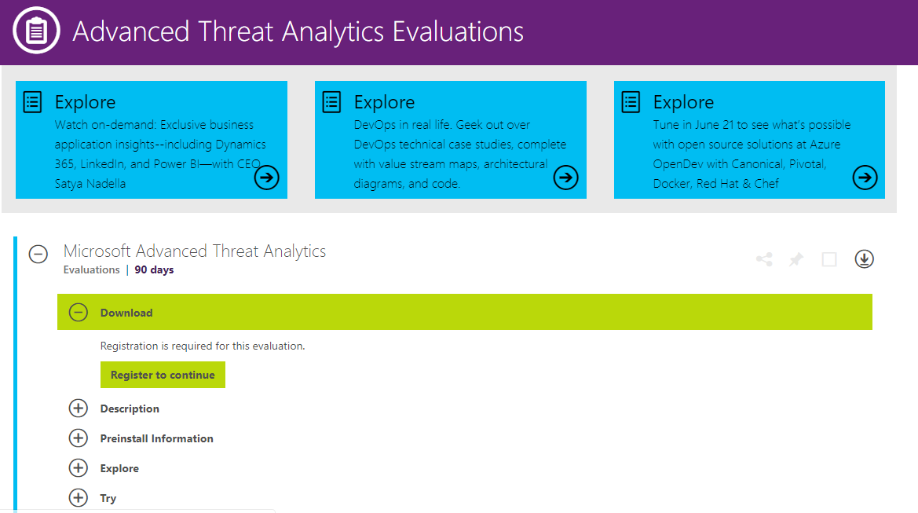

1. Click **Register to continue** under **Download** section.
2. Enter the details and click **Continue**. On clicking continue the downloading will start automatically, if not click the button **Download** and download **ATA1.8.1.iso**.

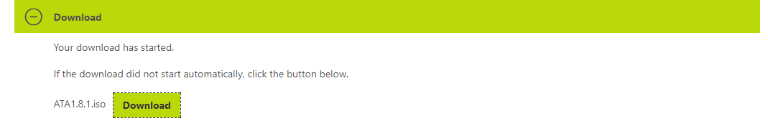

1. Extract the downloaded file **ATA1.8.1.iso** and run **Microsoft ATA Center Setup.EXE** as an Administrator and follow the setup wizard. If Microsoft .Net Framework is not installed, you are prompted to install it when you start installation. You may be prompted to reboot after .NET Framework installation.
2. On the **Welcome** page, select the **language** to be used for the ATA installation screens and click **Next**.

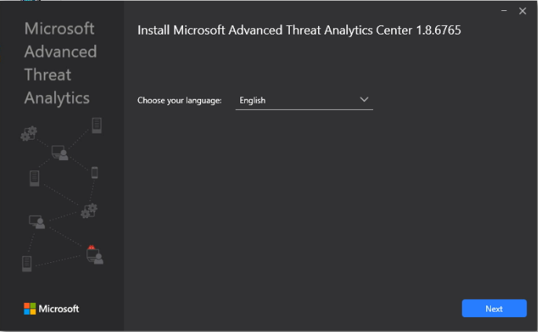

1. Read the Microsoft Software License Terms and if you accept the terms, click the check box, and then click **Next**.

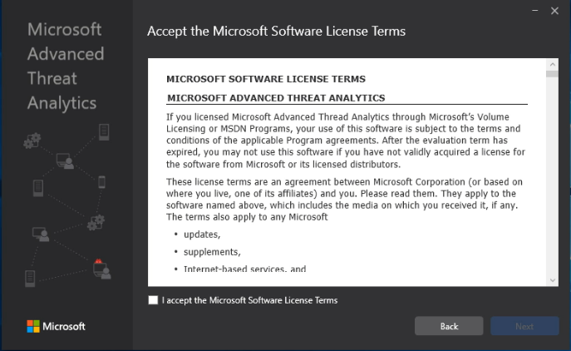

1. It is recommended that you set ATA to update automatically. If Windows isn't set to do this on your computer, you get the **Use Microsoft Update to help keep your computer secure and up to date** screen. Select **Use Microsoft Update when I check for updates (recommended)**. Then click **Next**.

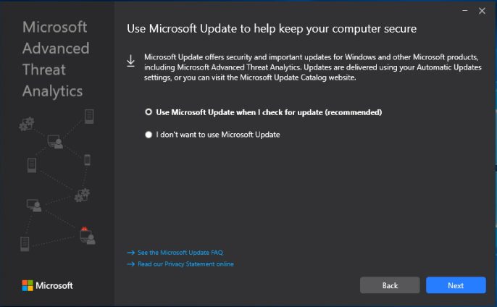

1. On the **Configure the Center** page, enter the information based on your environment – Installation Path, Database data path and Center Service SSL Certificate.

**Installation Path -** This is the location where the ATA Center is installed. By default, this is %programfiles%\Microsoft Advanced Threat Analytics\Center.

**Database Data Path -** This is the location where the MongoDB database files are located. By default, this is %programfiles%\Microsoft Advanced Threat Analytics\Center\MongoDB\bin\data.

**Center Service SSL Certificate -** This is the certificate that is used by the ATA Console and ATA Center service. Click the key icon to select a certificate installed or check self-signed certificate when deploying in a lab environment. You have the option to **create a self-signed certificate**.

Then click **Install** to install the ATA Center and its components.

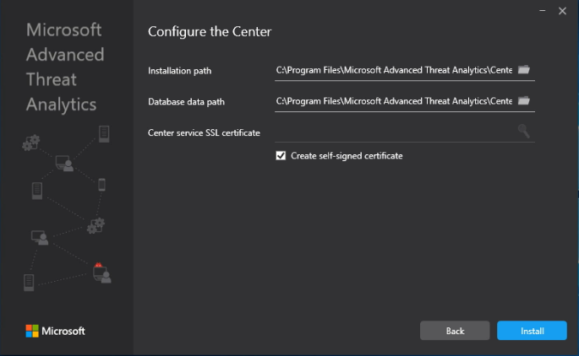

1. The components that are installed and configured during the installation of ATA Center are - ATA Center service, MongoDB, Custom Performance Monitor data collection set and Self-signed certificates (if selected during the installation).

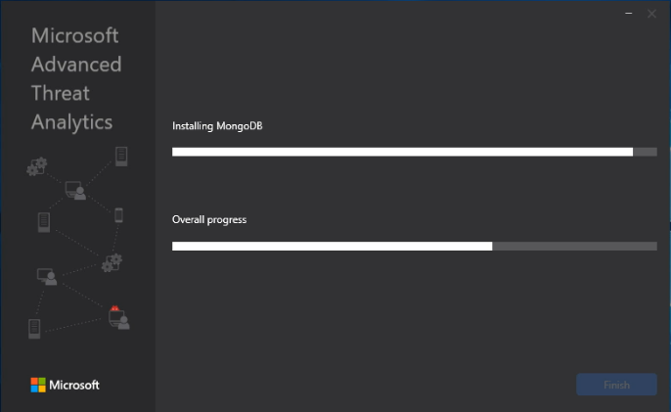

1. When the installation completes, click **Launch** to open the **ATA Console** and complete setup on the **Configuration** page.

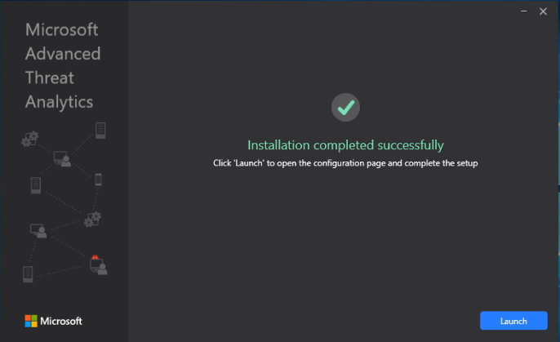

1. Choose browser to open Microsoft ATA Console.
2. You receive a warning related to the certificate, this is normal and you should click **Continue to this website**.

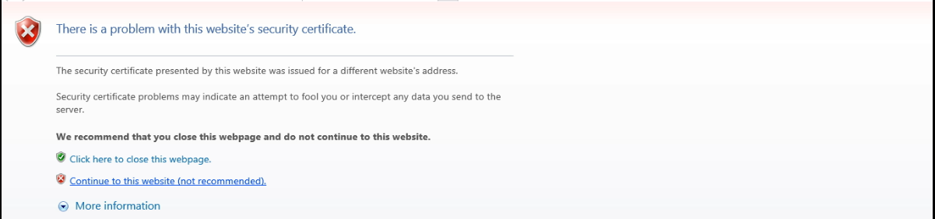

1. Welcome to Microsoft Advanced Threat Analytics page will open. You will be brought automatically to the **General settings** page to continue the configuration and the deployment of the ATA Gateways.

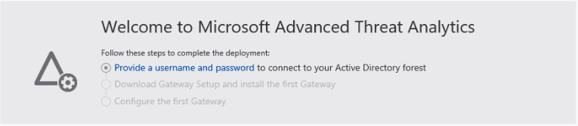

1. Now provide a **Username** and **Password** to connect to your **Active Directory Forest**.
2. Enter the information – Username (for ex. ATAUser), Password (for ex. Password@123) and Domain (for ex. corp.labdomain.com). Then, click **Save**.
3. You can also click **Test connection** before saving the details to test connectivity to the domain and check that the credentials supplied provide access. This works if the ATA Center has connectivity to the domain.

